Haiti Security Guide

This document is intended for short to long-term international assignees (1-18 months). Please review the following information carefully and pay particular attention to the site-specific rules at the end of the document. You are responsible for following all outlined guidance.
Contents

- Essential Information and Reminders
- Country Context
- ZL Context
- Risk Context
- Transportation Guidance
- Emergency Communication Protocols
- Incident Response Guidance
- Division of Responsibilities
- LGBT Guidance

Essential Information and Reminders

Reminders: Haiti is a high-risk country and vigilance must remain high at all times. International assignees are expected to take precautions to ensure their safety; if you have any questions, please be in touch with a member of the Haiti Security Team.
Contact Info:

Contact Name | Contact Title | Contact Number
Ernst Montoban | S&S Point Person: Local Nationals, Local Risk Context | +509-31-70-1588
Liz Campa | S&S Point Person: Visitors, Expatriates | +1-312-912-3743 (US and Whatsapp)  +509 4891 0233 through July 31, 2018
Coralie Noisette | Backup S&S Point Person: Visitors, Expatriates | +509-46-80-82-61
Marc Julmisse | S&S Point Person: Medical Situations | +1-909-359-8057
Andrea Tibbetts | Global S&S Program Officer | +1-617-334-5280
Ovation  (PIH Travel Agency) | Email: pihtravel@ovationtravel.com | Phone: 857-202-4857

Please note that this Security Guide does not contain comprehensive information on the risks associated with Haiti. It has been prepared by the ZL security team to the best of its ability but should be supplemented with independent research and active communication with the security team.

Country Context

History: Even before the devastating 2010 earthquake, the island nation of Haiti was already one of the poorest countries in the Western Hemisphere and one of the poorest in the world. Before the earthquake, Haiti’s per capita income fell below two dollars a day, at about $660 annually. At the same time, the health of the Haitian people also ranks as the worst in the hemisphere.
Haiti has the worst malnutrition, the highest rates of infant and maternal mortality, and the worst AIDS epidemic in the Americas. Nearly half the population is chronically undernourished. Of every thousand children born in Haiti, 71 die before reaching the age of 5, in stark contrast with Dominican Republic where the rate is 23 deaths for every 1000 live births.
HIV, tuberculosis and diarrheal disease are among the top ten causes of adult mortality. Maternal mortality, largely due to obstructed labor and hemorrhage, is at 380 per 100,000 live births, compared to less than 28 per 100,000 in the United States and only 4 per 100,000 in Sweden.
Though poor in wealth and infrastructure, Haiti is a country rich in culture and history. Originally a French slave colony, Haiti was founded by a revolution on January 1, 1804 and became the first black republic in the world. It was the first country to break the chains of slavery, to force Napoleon to retreat, and the only to help Simón Bolívar liberate the indigenous people and slaves of Latin America. Tragically, its history of liberty and self-determination has drawn two centuries of political and economic ire from powerful countries, resulting in policies that have served to impoverish the people of Haiti.
Port au Prince Overview: Port au Prince is a high-risk city and poses several risks to visitors. Short-term visitors are not permitted to walk anywhere outside in PaP, day or night. Transportation will be coordinated by ZL.
Cultural Notes: Haitians who work in the formal sector tend to wear business-style clothing during the work-day, and reserve casual clothing for outside of work. Visitors should dress conservatively while in country, please be mindful of this when packing. From November-March day temperatures are in the 70s-80s F/23-32 C and nights are in the 60s-70s F/15-27 C. The rainy season is July-November. During the rainy season there is an increased presence of mosquitos and visitors may want to bring insect-repellent to avoid contracting a mosquito-carried virus. The mountains are always about 10 degrees F/5 C cooler. Take a light sweater no matter when you go: Evenings can be cool in the mountain areas, so please bring comfortable sleeping apparel.

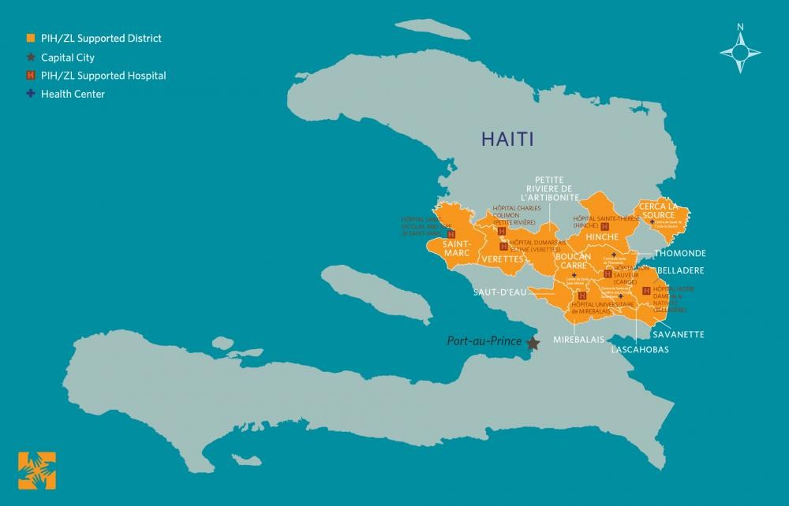

ZL Context

ZL History in Country: Zanmi Lasante (ZL), Partners in Health’s affiliated organization, is our flagship project—the oldest, largest, most ambitious, and most replicated. ZL operates clinics and hospitals at 12 sites across Haiti’s Central Plateau and lower Artibonite. ZL pioneered the use of accompagnateurs (community health workers) to deliver quality health care to people living with chronic diseases such as HIV and tuberculosis. In1998, PIH/ZL launched the world’s first program to provide free, comprehensive HIV care and treatment in an impoverished setting. ZL's HIV Equity Initiative is now a global model for the treatment of complex diseases in community settings.
To truly treat someone living with HIV, tuberculosis, or any number of other diseases, it is vital to address the root causes and socio-economic factors of those conditions. That’s why ZL supports dozens of schools, hundreds of farms, housing and water projects throughout the region, and a facility that produces Nourimanba, a peanut and vitamin supplement for treating malnourished children.
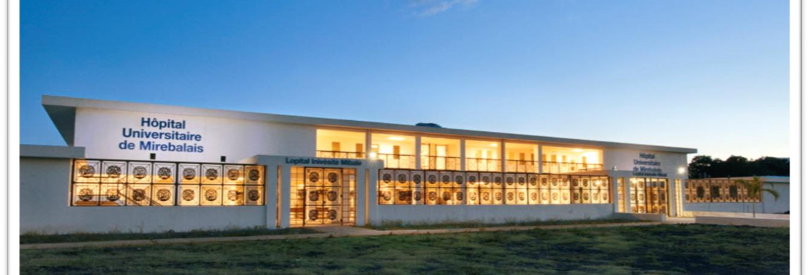
University Hospital of Mirebalais
After opening hospital services in a phased approach in March 2013, this 205,000-square foot, 300-bed facility offers a level of care never before available at a public facility in Haiti. And at a time when Haiti desperately needs skilled professionals, University Hospital in Mirebalais is providing high-quality education for the next generation of Haitian nurses, medical students, and resident physicians.
When a magnitude 7.0 earthquake devastated Port-au-Prince, ZL responded quickly and effectively, providing care to hundreds of thousands who fled to Haiti’s Central Plateau and Artibonite regions and establishing four health outposts in Port-au-Prince. ZL also ramped up mental health and psychosocial programs, farming initiatives, and education projects.
Since the earthquake, at over 1 million people across Haiti have become sick from cholera and more than 10,000 have died. In response, ZL built and staffed treatment centers and launched a large-scale community health intervention. In partnership with the Haitian government organization GHESKIO, PIH also launched the country’s first cholera vaccination campaign, which targeted 100,000 vulnerable people. To this day, ZL is the only organization in all of Haiti that has maintained all 10 of its cholera treatment centers opened since October 2010.
Current ZL Presence: Today, Zanmi Lasante is the largest non-government health care provider in Haiti, serving a direct population of 1.3 million and over 3 million people across the country (~10% of the total population) with a staff of about 6,000. Recent statistics include:
- 1,107,635 total outpatient visits during FY17 (July 2016-December 2017)
- 12,125 children enrolled in nutrition program in FY18 (USN, PTA, PNS)
- 13,784 children received educational assistance
- 14,363 patients on ARVs as of December 2017 reported
- Nearly 80,000 pregnant women seen in antenatal clinics
- 16,495 facility-based deliveries across all ZL sites in FY17
- Average 15,000 new family planning users each year
- 1,700 new tuberculosis patients began treatment
- Treated over 145,000 patients for cholera since October 2010
Zanmi Lasante’s Commitment:
- Zero deaths under 5 due to malnutrition
- Zero preventable maternal deaths in childbirth
- Zero mother-to-child transmission of HIV (PMTCT)
- Zero deaths from Tuberculosis
Risk Context
Risk Rating: High
Notable Security Information: Ensure you are registered with your local embassy. The safety of our staff and visitors is our utmost priority. However, as in any location, security risks do exist and common sense precautions are necessary. If at any time, you are confronted, surrender valuables, defer to Haitian staff/native Creole speakers, and remain calm and non-threatening.
Notable Medical Information: Mirebalais has a high presence of rabies and tetanus; visitors should ensure their vaccinations are up to date. If you fall ill at any point during your trip, be in contact with a Safety and Security Point Person immediately.
Protecting Yourself:
- Walking is prohibited at night in most sites and is strictly controlled during the day in PaP; review the site specific rules at the end of this document for full direction
- Pack lightly when traveling in the open; avoid carrying large bags or laptop bags, avoid wearing flashy jewelry and do not travel with your passport unless necessary. If you do carry your passport, ensure you have a secure copy. Reduce the valuables you have on your person in any unsecured location.
- Do not travel alone after dark.
- Be aware of your surroundings. Criminals are likely to strike in crowded areas or areas where there are confused individuals.
- Be aware of anyone loitering around ATMs; ask an SSPP if it is safe to withdraw money at an ATM location before doing so.

Transportation Guidance

Preferred Methods of Transportation: All ZL related travel within Haiti will include accompaniment by a ZL staff member. There is a curfew in place for the entire Port-au-Prince metropolitan area between 9PM and 6AM, so no travel out of or between sites is permitted during this time unless specifically arranged by the ZL security team. Additionally, for our rural sites, we ask that you arrive and settle in no later than 4:00pm, and not travel outside alone after sunset. Exceptions to these rules will only be made in the case of an emergency.
Additional, site-specific details are at the end of this guide.
Traveling within the Capital City: Travel is expected to take place between 6am-9pm with the support of a ZL driver or approved transport.
Traveling in Sites: Travel during daylight hours whenever possible, supplemented by travel with a ZL driver or approved transport after dark. Please refer to site-specific guidance at the end of this document for detailed guidance.
Personal Travel: Personal travel requires advanced approval by the Haiti Safety Team. Please emails HaitiSafetyTeam@pih.org with an outline of your proposed trip and the team will confirm whether it is safe to proceed. You can then contact Magalie to coordinate transport.
Travel Accidents: In the event of a travel accident, your ZL driver will know how to best navigate the situation.
Emergency Communication Protocols
Mirebalais Whatsapp Group: All international assignees should participate in the Mirebalais Whatsapp group for up to date security information. Most communications will be done through this group unless there is an emergency that necessitates the use of the phone tree.
Standing Information: Ensure your phone is charged with adequate credit at all times, particularly in times of unrest. Update your SSPPs if your phone number changes.
Routine Updates: Routine updates will be done via Mirebalais Whatsapp group.
Emergent Threat Notification: Threat notifications will come through a phone call or through the Mirebalais Whatsapp group depending on the context.
Emergency Communications: Urgent messages and/or staff accounting will be done through phone calls.
Incident Response Guidance
Minor Incidents (incidents unlikely to have long-term effects on individual or ZL): Reach out to your SSPPs to report the incident and request any support needed. This outreach can be done by phone or email.
Serious Incidents (incidents likely to have some long-term effect on individual or ZL): Call the SSPPs immediately to receive support. Even if you are not sure you need help, PIH may have insurances/resources that can be useful to you.
Critical Incidents (life or program threatening incidents): Call the SSPPs or ED immediately.
Reporting Incidents: All staff, including employees, volunteers, affiliated partners, etc., are required to report incidents that befall them directly or of which they are indirectly involved or knowledgeable. Employees are encouraged to report all incidents even if they are not sure whether they are “reportable” or not.
Partners in Health (PIH) defines a reportable incident as any incident that involves:
- A PIH or ZL employee, volunteer, contractor or person working or traveling on behalf of PIH or ZL;
- Property purchased with PIH or ZL grants, donations or other PIH or ZL procured funds or;
- A third party impacted as a result of PIH or ZL staff or activities

Division of Responsibilities

Individual Responsibilities:
- Adhere to the domestic and international travel registration processes (outlined below)
- Comply with all safety measures identified by the Global and Country S&S Programs (i.e. curfews, no go zones, etc.) including those provided in written materials and communicated by teams over email, text, etc.
- Review all provided S&S materials
- Report all reportable incidents (incident reporting guidelines are available on Sharepoint)
- Highlight any security concerns in a timely manner

Safety and Security Point People Responsibilities:
- Monitoring the country risk environment and adjusting procedures as needed
- Briefing new staff and visitors about the country risk environment and ensuring they are prepared to safely conduct our work
- Keeping staff and visitors informed of evolving threats and advising them accordingly
- Responding to incidents with the support of the global program and reporting incidents to the Program Officer of Safety, Security and Travel
- Working in partnership with the global program to maintain country materials

Global Safety and Security Responsibilities:
- Developing and maintaining organization-wide resources and initiatives
- Maintaining organizational relationships with insurance and service providers
- Establishing organizational goals, procedures and best practices for safety and security
- Partnering with countries to monitor risk environments, develop site-specific protocols and respond to incidents
- Coordinating across key stakeholders to ensure consistency and continuity

PIH Leadership Responsibilities:
- Fostering an organizational environment that emphasizes the importance of safety and security
- Participating in trainings that render them prepared to respond to incidents of all calibers
- Factoring safety and security into budgetary decisions and ensuring sufficient resources are available for safety and security initiatives, resources and incident response.

LGBT Guidance

US Dept. of State Guidance: No laws criminalize sexual orientation or consensual same-sex conduct between adults, nor were there any reports of police officers actively perpetrating or condoning violence against members of the lesbian, gay, bisexual, transgender, and intersex (LGBTI) community in 2017.
While no laws criminalize the changing of one’s gender or sex, local attitudes remained hostile to outward LGBTI identification and expression, particularly in Port-au-Prince. Religious and other conservative organizations actively opposed the social integration of LGBTI persons and discussion of their human and civil rights. Leading presidential candidates publicly note that they would not and should not consider any type of LGBTI rights legislation, particularly one calling for marriage equality.
No antidiscrimination laws protect LGBTI persons and minority groups. Additionally, traditional mistrust of law enforcement and judiciary officials, along with a historically low rate of successful prosecution of SGBV and related crimes, hinder LGBTI advocates and community members from successfully cooperating to reduce violence and discrimination experienced by the group. Some civil society advocates claim that in the greater Port-au-Prince area, HNP authorities are inconsistent in their willingness to document or investigate LGBTI persons’ claims of abuse.
LGBTI advocacy groups in the capital report a greater sense of insecurity and less trust of government authorities than groups in rural areas. Several local NGOs and international organizations provide direct support to LGBTI persons who allege discrimination due to their sexual orientation or gender identity or being victims of SGBV.
Context for Site: Haiti is a country where LGBT matters are not openly discussed and most people keep this a private matter for security reasons. Please reach out to Andrea Tibbetts to discuss this in more detail and strategize on how best to approach this matter while you are in Haiti.

Haiti Site Policies and Notes

These policies are intended to help visitors and international assignees conduct themselves safely in the various areas in Haiti in which they may be working. Each site in Haiti has a unique risk environment and therefore appropriate behavior is not consistent between them. International assignees and visitors are expected to conduct themselves in a manner consistent with these notes, which have been developed and finalized by the Haiti Safety Team.
Port au Prince
Subject | Short-Term Assignees  (<9 months) | Long-Term Assignees  (>9 months)
Walking (daylight) | Strongly discouraged but acceptable for short distances in Petion-ville after a security briefing  Fully prohibited outside Petion-ville | Discouraged but acceptable for short-medium distances in Petion-ville after a security briefing  Fully prohibited outside Petion-ville
Walking (after dark) | Prohibited | Prohibited
Self-Driving | Prohibited | Prohibited for at least one year from date of arrival; after then conversation with security team required to make a plan to transition
Transportation | All public transportation prohibited, be in contact with ZL for approved taxi companies  Contact Ernst for alternative transportation methods | All public transportation prohibited, be in contact with ZL for approved taxi companies  Contact Ernst for alternative transportation methods
Accommodations | Best Western, Karibe, Kinam, Marriot, Servhotel, La Lorraine, Oasis, Le Rancho, La Reserve | Petion-ville, Peguy-ville, Vivy-Michel, Montagne Noir  Apartment must be approved by head of ZL security (Ernst) and Loune before lease is signed
Arrival/Departure | Do not share your itinerary with anyone who does not need to know
Personal Movement | - Process  - Use Haiti Safety Team email to verify trip is approved from a safety perspective  - Once approval is acquired, contact Magalie to coordinate an approved driver  - Individuals are responsible for all costs, including gas, driver time, driver food, etc.  - Anything outside this process (including domestic or Dominican Republic flights) must be cleared by Ernst  - Jacmel trips must be done through Tour Haiti  - Renting a car either self-driven or with a driver must be approved explicitly by ZL  - Do not attend any event with a large crowd, including concerts, Carnival, Saut d’Eau festival, etc.; contact Haiti Safety Team if you are interested in an event and it will be determined whether it is appropriate or not
Site Contact | Elizabeth Campa (+1-312-912-3743)
ZL Global Contact | Ernst Montoban (+509-31-70-1588)
PIH Global Contact | Andrea Tibbetts (+1-617-334-5280)
Items of Note | - Absolutely no visits to banks or exposed ATMs in PaP; there are ATMs in hotels and grocery that may be appropriate but extreme caution must be taken  - Saturdays are very busy; Sundays most things are closed  - Register with the US Embassy  - Don’t try to pass a strike or a roadblock; do not be by the windows if a strike is passing your accommodation

Mirebalais
Subject | Short-Term Assignees  (<9 months) | Long-Term Assignees  (>9 months)
Walking (daylight) | Appropriate; be aware of roads and dogs
Walking (after dark) | Prohibited  Please note, this has been adopted due to increased insecurity in the past year
Self-Driving | Prohibited | Prohibited for at least one year from date of arrival; after then conversation with security team required to make a plan to transition
Transportation | All public transportation prohibited, be in contact with ZL for approved taxi companies  Contact Ernst for alternative transportation methods
Accommodations | Accommodations are coordinated by ZL and will be identified for assignees
Personal Movement | - Process  - Use Haiti Safety Team email to verify trip is approved from a safety perspective  - Once approval is acquired, contact Magalie to coordinate an approved driver  - Individuals are responsible for all costs, including gas, driver time, driver food, etc.  - Anything outside this process (including domestic or Dominican Republic flights) must be cleared by Ernst  - Jacmel trips must be done through Tour Haiti  - Renting a car either self-driven or with a driver must be approved explicitly by ZL  - Walking at night is prohibited; ZL transportation can be arranged for personal trips  - Hiking during the day is appropriate; make sure someone at site is aware of where you are going  - Do not attend any event with a large crowd, including concerts, Carnival, Saut d’Eau festival, etc.; contact Haiti Safety Team if you are interested in an event and it will be determined whether it is appropriate or not
Site Contact | Marc Julmisse (+1-909-359-8057)
ZL Global Contact | Ernst Montoban (+509-31-70-1588)
PIH Global Contact | Andrea Tibbetts (+1-617-334-5280)
Items of Note | - Tetanus and rabies vaccinations need to be up to date  - ATM in town is sometimes out of money; contact Coslee or Magalie for help in procuring cash  - Register with the US Embassy

Subject | Short-Term Assignees  (<9 months) | Long-Term Assignees  (>9 months)
Walking (daylight) | Appropriate; be aware of cars
Walking (after dark) | Prohibited outside the campus
Self-Driving | Prohibited | Prohibited for at least one year from date of arrival; after then conversation with security team required to make a plan to transition
Transportation | All public transportation prohibited  Be in contact with Magalie for transportation needs
Accommodations | Campus housing will be organized by ZL
Personal Movement | - Process  - Use Haiti Safety Team email to verify trip is approved from a safety perspective  - Once approval is acquired, contact Magalie to coordinate an approved driver  - Individuals are responsible for all costs, including gas, driver time, driver food, etc.  - Anything outside this process (including domestic or Dominican Republic flights) must be cleared by Ernst  - Only use trusted / appointed drivers for transportation outside the area
Site Contact | Ernst Montoban (+509-31-70-1588)
ZL Global Contact | Ernst Montoban (+509-31-70-1588)
PIH Global Contact | Andrea Tibbetts (+1-617-334-5280)
Items of Note | - Register with the US Embassy
Cange

Subject | Short-Term Assignees  (<9 months) | Long-Term Assignees  (>9 months)
Walking (daylight) | Appropriate
Walking (after dark) | Acceptable as long as precautions are taken and vigilance is high
Self-Driving | Prohibited | Prohibited for at least one year from date of arrival; after then conversation with security team required to make a plan to transition
Transportation | All public transportation prohibited  Be in contact with Magalie for transportation needs
Accommodations | Campus housing will be organized by ZL
Personal Movement | - Process  - Use Haiti Safety Team email to verify trip is approved from a safety perspective  - Once approval is acquired, contact Magalie to coordinate an approved driver  - Individuals are responsible for all costs, including gas, driver time, driver food, etc.  - Anything outside this process (including domestic or Dominican Republic flights) must be cleared by Ernst  - Only use trusted / appointed drivers for transportation outside the area
Site Contact | Duranda Joseph
ZL Global Contact | Ernst Montoban (+509-31-70-1588)
PIH Global Contact | Andrea Tibbetts (+1-617-334-5280)
Items of Note | - Register with the US Embassy
Hinche

Subject | Short-Term Assignees  (<9 months) | Long-Term Assignees  (>9 months)
Walking (daylight) | Appropriate
Walking (after dark) | Prohibited
Self-Driving | Prohibited | Prohibited for at least one year from date of arrival; after then conversation with security team required to make a plan to transition
Transportation | All public transportation prohibited  Be in contact with Magalie for transportation needs
Accommodations | Guest houses available with adequate security
Personal Movement | - Process  - Use Haiti Safety Team email to verify trip is approved from a safety perspective  - Once approval is acquired, contact Magalie to coordinate an approved driver  - Individuals are responsible for all costs, including gas, driver time, driver food, etc.  - Anything outside this process (including domestic or Dominican Republic flights) must be cleared by Ernst  - Only use trusted / appointed drivers for transportation outside the area
Site Contact | Jack St. Fleur
ZL Global Contact | Ernst Montoban (+509-31-70-1588)
PIH Global Contact | Andrea Tibbetts (+1-617-334-5280)
Items of Note | - Register with the US Embassy
Saint Marc

